Historical landmarks

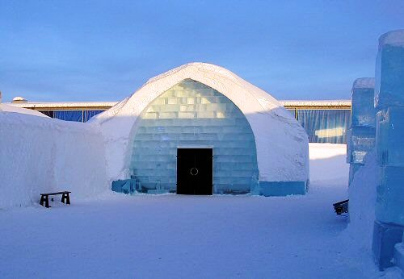 The Ice church

Match the landmark with the correct alternative

a) Romania

b) Italy

c) Poland

d) Sweden

The correct alternative is: d.

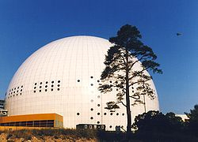 The Globe

Match the landmark with the correct alternative

a) Spain

b) Sweden

c) Poland

d) Bulgaria

The correct alternative is: b.

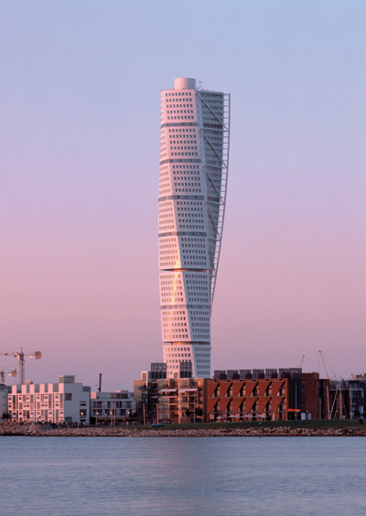 Turning Torso

Match the landmark with the correct alternative

a) Sweden

b) Italy

c) Poland

d) Spain

The correct alternative is: a.

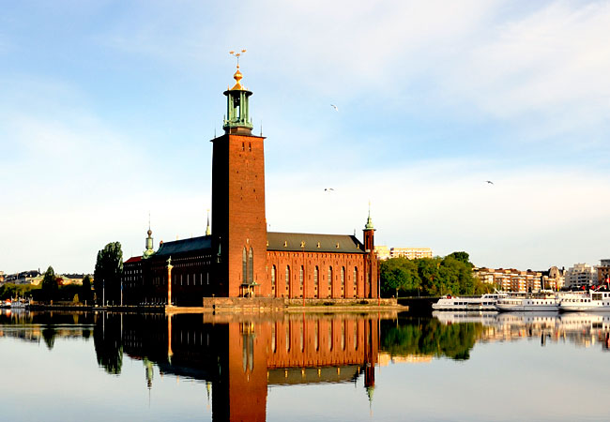The City Hall of the Capital

Match the landmark with the correct alternative

a) Romania

b) Italy

c) Poland

d) Sweden

The correct alternative is: d.

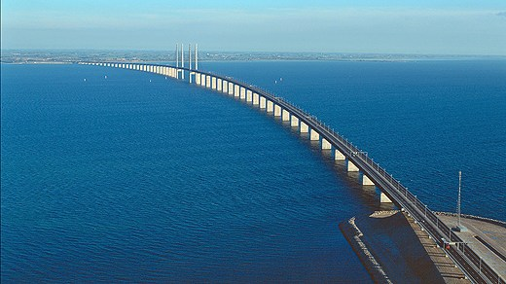 Öresundsbron

Match the landmark with the correct alternative

a) Sweden

b) Italy

c) Romania

d) Turkey

The correct alternative is: a.